Week 3: 8-12 June 2026
This week, I performed layer analysis for YOLO26n and planned for profiling for the next week.

1. Layer Types in YOLO26n
First, we take a look at what layer types YOLO26n has:

Layer | Appear counts | Position in YOLO26n | What is does
Convolution [2], [3] | 7 | Convolution layers appear in both the backbone and neck.  Also appeared for down-sampling (stride = 2). | A convolution layer applies learnable kernels over local image regions to extract visual features such as edges, textures, shapes, and object parts.  Kernel size  - e.g. 3x3 means a scanner looks at 3x3 in an image at a time  Stride  - e.g. 2 means the scanner moves two pixels each step when scanning  Channels  - e.g. 8 means the output will have 8 features
Batch Normalization [3], [8] | - | It is usually packaged in the Convolution module.  Namely Convolution -> Batch Normalization -> SiLU Activation | Stabilizes intermediate feature distributions and helps neural networks train faster and more reliably.
Sigmoid Linear Unit (SiLU) Activation [3], [9] | - | It is usually packaged in the Convolution module. | A smooth non-linear activation function that keeps strong positive responses while smoothly suppressing weak or negative responses.
C3 with kernel size 2-style bottleneck blocks (C3k2) [4] | 8 | It appears repeatedly in the Backbone and Neck; it is the main feature-extraction block. | C3k2 is a faster CSP-style bottleneck block that improves feature transformation while reducing redundant computation compared with plain stacked convolution blocks.  e.g. in the current state, two features exist:  - Car  - Human leg  The feature car can stop further identifying, whereas the human leg requires further processing to confirm whether it is human.
Spatial Pyramid Pooling Fast (SPPF) [4] | 1 | Late backbone, typically located in the deep P5/32 feature map. | View the same image simultaneously using small, medium, and large fields of view.
C2 with Parallel Spatial Attention (C2PSA) Attention [2], [4] | 1 | Late backbone (when the feature map is relatively low), after SPPF | Using an attention mechanism, the model learns which spatial regions are more important.
Upsample [2], [5] | 2 | In Neck / Head, used for P5->P4 and P4->P3. | Enlarge the low-resolution feature map, for example, from 20x20 to 40x40.
Concatenate [2], [5] | 4 | In Neck / Head, usually after Upsample. | Merge two feature maps along the channel dimension.
Detect [2], [10] | 1 (3) | The final layer of YOLO26n | Output bounding boxes, class probabilities, and confidence scores.
Table 1: Layers in YOLO26n and their Functions

Table 1 shows the general functions of each layer. For this project, we may want to focus more on how each layer affects the model’s accuracy, size, and speed:

Layer | Role in Object Detection | Estimated Impacts on Model Accuracy, Size, and Speed
Convolution [3] | Higher kernel size can see a bigger area  Higher stride will see fewer details  Higher channels mean more features | Accuracy – High  Extracts core visual features  Size – High  Channels and kernels determine the number of parameters  Speed – High  Primary source of computation, but well-suited for acceleration
Batch Normalization [3], [8] | Batch normalization improves training stability and convergence by normalizing intermediate activations. | Accuracy – Medium  Stable training  Size – very low  Speed – Low  Fused into the convolution layer, reducing its standalone runtime cost.
SiLU Activation [9] | Sharpening | Accuracy – Medium  Smooth non-linearity  Size – Almost no parameters  Speed – Medium  involves a sigmoid operation
C3k2 [2], [4] | In backbone: responsible for extracting deeper object features  In neck: responsible for organizing fused features to improve small / medium / large object detection. | Accuracy – Very high  Primarily high in feature extraction/fusion  Size – High  Efficiency compared to regular Convolution  Speed – High  Often a latency hotspot
Spatial Pyramid Pooling Fast (SPPF) [4], [7] | SPPF helps the model capture wider contextual information, which is useful when objects appear in complex traffic scenes or with partial occlusion. | Accuracy – Medium to high  Increase context  Size – Low  Speed – Low to medium  Pooling is cheap but has memory cost
C2PSA Attention [4] | Focus less on unnecessary parts, such as skys and trees. | Accuracy – Medium to High  Attention strengthens important areas  Size – Medium  Speed – Medium to High
Upsample [5] | Upsampling brings deep semantic features back to a higher spatial resolution, which supports small-object detection in multi-scale feature fusion | Accuracy – Medium:  Helps with small-object detection  Size – No parameters  Speed – Low
Concatenate [3], [5] | By combining high-resolution spatial details with deeper semantic features, concatenation supports multi-scale object detection. | Accuracy – High  Fusion of multi-scale features  Size – has no direct parameters  But it increases the channel dimension and therefore increases the computation of later convolution layers.  Speed – Low  However, it may incur bandwidth costs.
Detect [1], [2] | P3 detects small objects  P4 detects medium objects  P5 detects large objects | Accuracy – Very high  Directly outputs box and class  Size – Medium  Speed – High  NMS-free end-to-end detection design, which reduces post-processing complexity during deployment.
Table 2: Layers in YOLO26n and their Effects on the Model

Based on the layer analysis in Table 2, the estimated profiling priority may be:
- C3k2
- Conv
- Detect head
- C2PSA
- SPPF
- Upsample / Concatenate memory movement

- C3k2 and Conv are likely to account for a large portion of latency and FLOPs because they contain the main convolution-based feature extraction operations [4].
- The detection head directly affects deployment complexity because YOLO26 uses an end-to-end NMS-free detection design [1].
- Upsample and Concatenate have few or no learnable parameters, but they can increase memory movement because they resize and merge feature maps [5].

2. YOLO26’s Workflow
To further understand the functions of each layer in YOLO26n, a workflow of YOLO26n is needed.
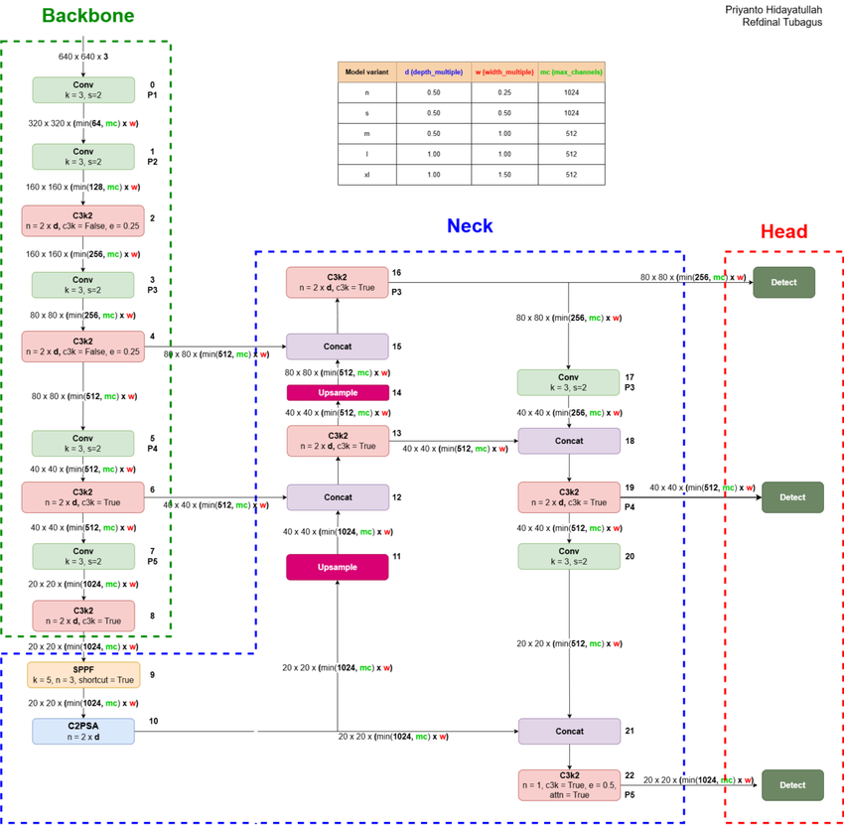
Figure 1: YOLO26 Architecture

Structure [1], [2]
- RGB Image
- Backbone (Extract Image Features)
- SPPF + C2PSA (Expand Receptive Range + Focus on Important Regions)
- Neck (Fuse Small, Medium, and Large-Scale Features)
- Detect Head [2]
  - P3 Small Objects
  - P4 Medium Objects
  - P5 Large Objects
- Final Output
- Bounding Boxes + Classes + Confidence

The following table provides a top-level layer-by-layer analysis based on the official YOLO26n YAML architecture [1], [2].

Remark: P3/8 means the P3 feature map has 1/8 of the input image resolution.

Order | Stage | Layer | Output | Role in Detection | Effect on Model
0 | Backbone | Conv | P1/2 | Finds basic visual patterns | -
1 | Backbone | Conv | P2/4 | Reduces image size, increases features | Lowers later computation
2 | Backbone | C3k2 | P2/4 | Refines early features | Efficient feature extraction
3 | Backbone | Conv | P3/8 | Creates small-object feature scale | Keeps more spatial detail
4 | Backbone | C3k2 | P3/8 | Strengthens small-object features | Important but computationally heavier
5 | Backbone | Conv | P4/16 | Creates medium-object feature scale | Reduces feature-map size
6 | Backbone | C3k2 | P4/16 | Strengthens medium-object features | Balances accuracy and cost
7 | Backbone | Conv | P5/32 | Creates deep feature scale | Makes later processing cheaper
8 | Backbone | C3k2 | P5/32 | Extracts high-level object features | Useful for large-object detection
9 | Backbone | SPPF | P5/32 | Adds wider context | Low parameter cost
10 | Backbone | C2PSA | P5/32 | Focuses on important features | Attention cost is controlled
11 | Neck | Upsample | P4/16 | Enlarges deep features | No parameters, more memory movement
12 | Neck | Concat | P4/16 | Merges deep and medium features | Increases later channel computation
13 | Neck | C3k2 | P4/16 | Refines fused medium features | Improves detection with extra cost
14 | Neck | Upsample | P3/8 | Enlarges features for small objects | No parameters, more memory movement
15 | Neck | Concat | P3/8 | Merges deep and small-object features | Increases later channel computation
16 | Neck / Head | C3k2 | P3/8 | Produces final small-object features | Important for small-object accuracy
17 | Neck | Conv | P4/16 | Down-samples features to P4 | Supports feature fusion
18 | Neck | Concat | P4/16 | Merges P3 and P4 features | Improves medium-scale detection
19 | Neck / Head | C3k2 | P4/16 | Produces final medium-object features | Important for medium-object accuracy
20 | Neck | Conv | P5/32 | Down-samples features to P5 | Supports large-object fusion
21 | Neck | Concat | P5/32 | Merges P4 and P5 features | Improves large-scale detection
22 | Neck / Head | C3k2 | P5/32 | Produces final large-object features | Important for large-object accuracy
23 | Head | Detect | P3, P4, P5 | Outputs final detections | -
Table 3: Top-Level Layer-by-Layer of YOLO26n

To summarize, when an RGB image is processed by YOLO26, it first goes through the Backbone to extract features, then through the Neck to perform multi-scale fusion, and finally the Head outputs detections at three scales (big, medium, and small objects).

With that, it will be easier to think of model size shrinking and model acceleration in the future.

2.1 More About YOLO Layers (CSP, C3K2)
In YOLO, a Cross Stage Partial (CSP) style block means the input feature map is usually split into two parts:
- One part goes through several convolution / bottleneck layers to learn deeper features.
- The other part bypasses those layers and is kept as a shortcut-like path.
At the end, the two parts are concatenated or fused together. The main purpose is to:
- reduce repeated gradient information,
- lower computation cost,
- improve feature reuse,
- keep good detection accuracy with fewer parameters.

C3 with kernel size 2-style bottleneck blocks (C3K2) architecture:
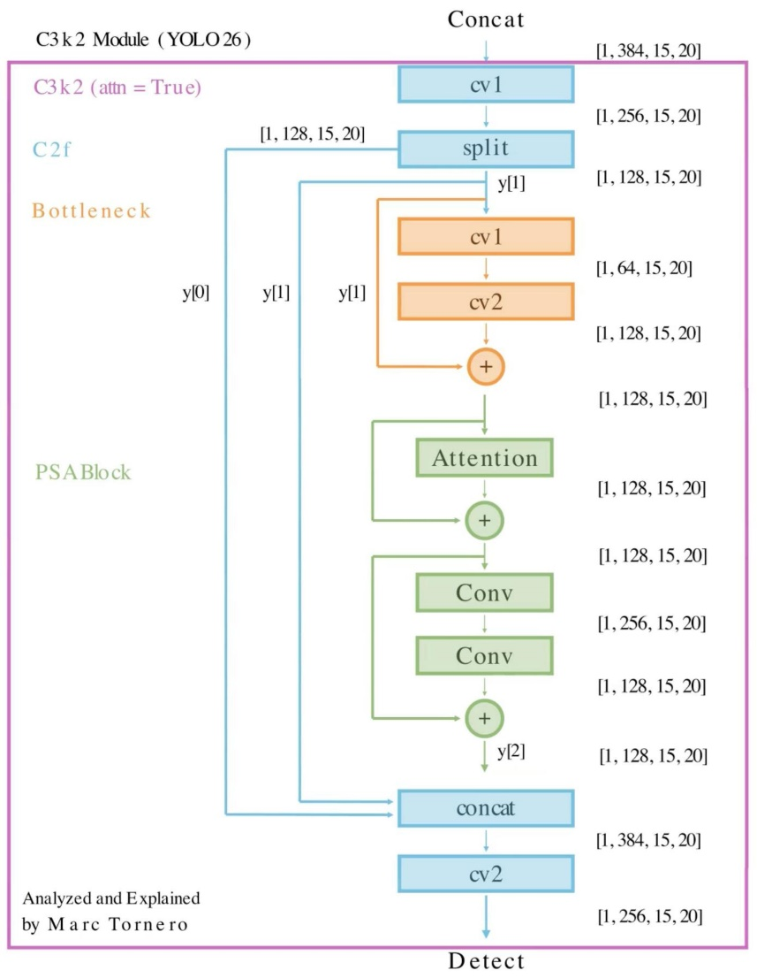
Figure 1.1: C3K2 Block

Official Ultralytics code confirms: C3k2 is a C2f-based CSP Bottleneck with two convolutions, and it selects internal modules based on parameters: it uses Bottleneck when c3k=False, C3k when c3k=True, and Bottleneck + PSABlock when attn=True. [15]

3. How The Origin YOLO26n Shrink Model Size
YOLO26n reduces model size mainly through nano-scale compound scaling. In the official YAML, the nano version uses depth scaling of 0.50 and width scaling of 0.25, which reduces the number of repeated blocks and channel width compared with larger YOLO26 versions [2].

4. YOLO26n Baseline Compare
The baseline is the published YOLO26n result [1], while my project result will be the edited YOLO26n trained on the MIO-TCD Localization dataset. The baseline comparison can be structured as follows:

Item | Published YOLO26n Baseline [2] | My Project YOLO26n Result
Model | YOLO26n | YOLO26n edited
Dataset | COCO benchmark in YOLO26 paper | MIO-TCD Localization
Input Size | 640 x 640 x 3 | 640 x 640 x 3
Parameters | 2.57 M | Measured from my environment
FLOPs | 6.1 GFLOPs | Measured from my environment
Accuracy Metric | mAP50-95 | mAP50-95 / mAP50
Purpose | General-object detection | Traffic-object detection
Table 4: Comparation Simulation

5. Next Step
For the next step, we need to Identify which YOLO26n layers are the slowest, most memory-intensive, and have the greatest impact on accuracy. Then decide which layers are worth FPGA acceleration, quantization, and pruning, and which layers need to retain high precision.

Tasks:
- Layer-wise profiling measures the latency, memory usage, FLOPs, and runtime cost of each YOLO26n layer to identify computational and memory bottlenecks.
- Layer-based error injections introduce controlled errors into specific layers, and measures the resulting accuracy degradation.
By combining profiling and error sensitivity results, we can identify which layers should be accelerated, quantized, pruned, or protected with higher precision.
Layers with high latency and low error sensitivity are strong candidates for aggressive optimization, while layers with high sensitivity should be optimized more carefully.

6. YOLO Testing
The original dataset is YOLO-friendly, but cannot be trained directly. Therefore, I converted the format:
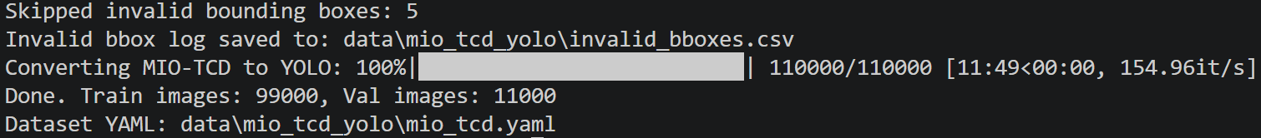
Figure 2: Pre-training YOLO Adapt Convention

I then performed a quick sanity check, with the following settings (very light weight):
- 1 epoch
- 1% of MIO-TCD train set
- 4 batches
- 320 image size
- On CPU

And here is the result:
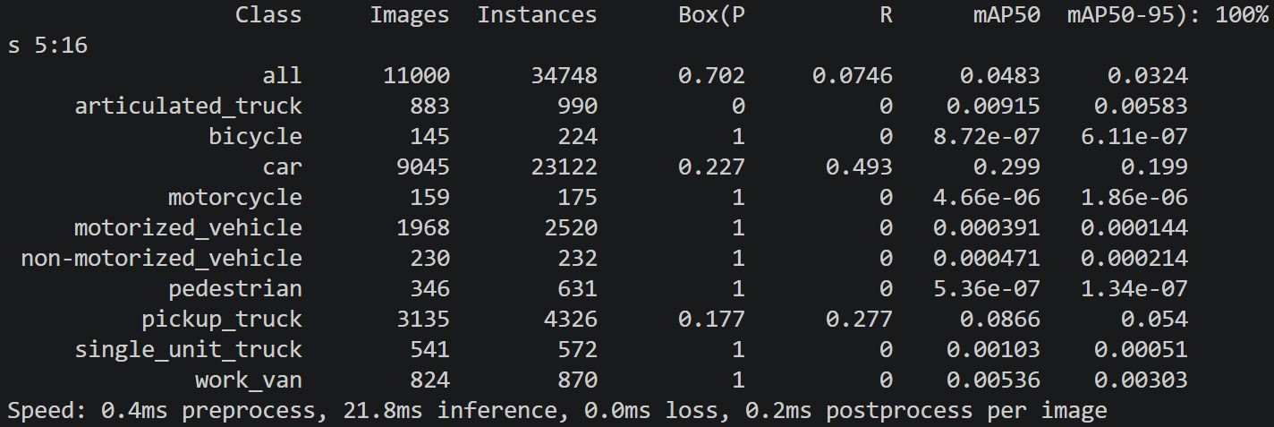
Figure 3: Training Results (Light training settings)

A preliminary YOLO26n training and validation pipeline was successfully established on the converted MIO-TCD Localization dataset. The model was able to load the dataset, train, and produce per-class validation metrics.

Metric | Meaning | Current Status
Images = 11000 | Number of validation images | Very large, validation will take time
Instances = 34748 | Number of validation bounding boxes | Many objects
Precision = 0.702 | How many predicted objects are correct | Seemingly good
Recall = 0.0746 | How many real objects were found | Very low
mAP50 = 0.0483 | Detection accuracy at IoU 0.5 | Very low
mAP50-95 = 0.0324 | COCO-style stricter mAP | Very low
Table 4: Training Results (Light training settings)

The initial validation result showed low recall and low mAP, indicating that the model has not yet sufficiently learned the dataset under the current short training setting. Further dataset verification and longer baseline training are required before deployment or backend comparison.

For the details of the data, it is as follows:
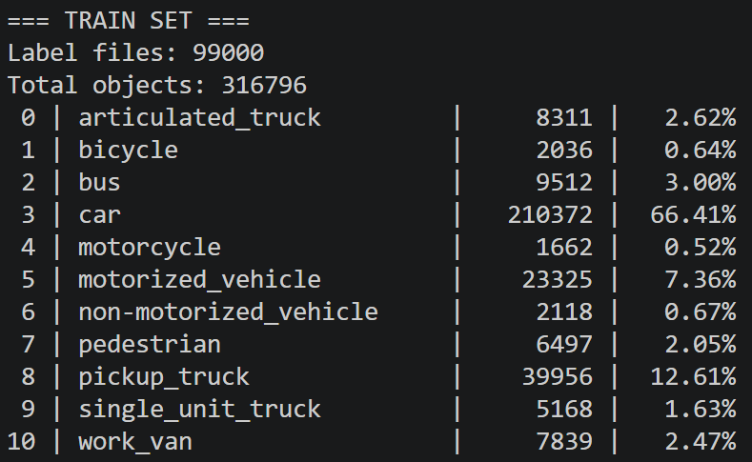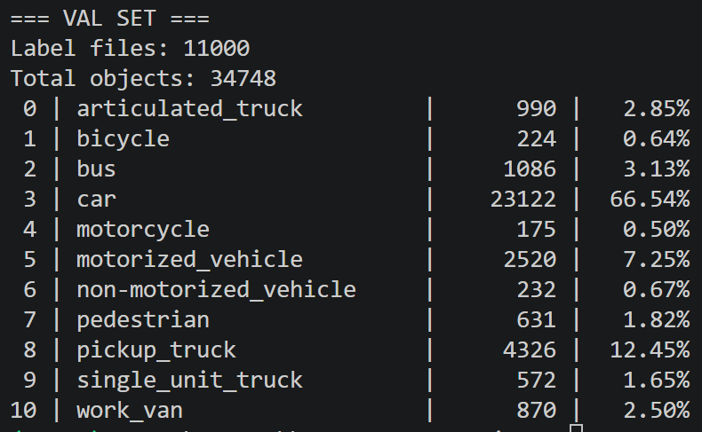
Figure 4: Dataset Details (temporary)

Finally, I tested on exporting the model as ONNX:
Figure 5: ONNX Exporting Test

This is my current state; I will explore YOLO26n more later.

References

[1] Jocher et al., Ultralytics YOLO26: Unified Real-Time End-to-End Vision Models, 2026. https://arxiv.org/abs/2606.03748

[2] Ultralytics, yolo26.yaml, 2026. https://github.com/ultralytics/ultralytics/blob/main/ultralytics/cfg/models/26/yolo26.yaml

[3] Ultralytics, Reference for ultralytics/nn/modules/conv.py, 2023. https://docs.ultralytics.com/reference/nn/modules/conv/

[4] Ultralytics, Reference for ultralytics/nn/modules/block.py, 2023. https://docs.ultralytics.com/reference/nn/modules/block/

[5] Lin et al., Feature Pyramid Networks for Object Detection, 2017. https://arxiv.org/abs/1612.03144

[6] Wang et al., CSPNet: A New Backbone that can Enhance Learning Capability of CNN, 2019. https://arxiv.org/abs/1911.11929

[7] He et al., Spatial Pyramid Pooling in Deep Convolutional Networks for Visual Recognition, 2014. https://arxiv.org/abs/1406.4729

[8] Ioffe and Szegedy, Batch Normalization: Accelerating Deep Network Training by Reducing Internal Covariate Shift, 2015. https://arxiv.org/abs/1502.03167

[9] Ramachandran et al., Searching for Activation Functions, 2017. https://arxiv.org/abs/1710.05941

[10] Wang et al., YOLOv10: Real-Time End-to-End Object Detection, 2024. https://arxiv.org/abs/2405.14458

[11] Dong et al., HAWQ: Hessian AWare Quantization of Neural Networks with Mixed-Precision, 2019. https://arxiv.org/abs/1905.03696

[12] Liang et al., Pruning and Quantization for Deep Neural Network Acceleration: A Survey, 2021. https://arxiv.org/abs/2101.09671

[13] Luo et al., MIO-TCD: A New Benchmark Dataset for Vehicle Classification and Localization, 2018. https://doi.org/10.1109/TIP.2018.2848705

[14] MIOvision, Localization Challenge Dataset, n.d. https://tcd.miovision.com/challenge/dataset.html

[15] Ultralytics, Reference for ultralytics/nn/modules/block.py, 2023. https://docs.ultralytics.com/reference/nn/modules/block

